Development of Diaphragm

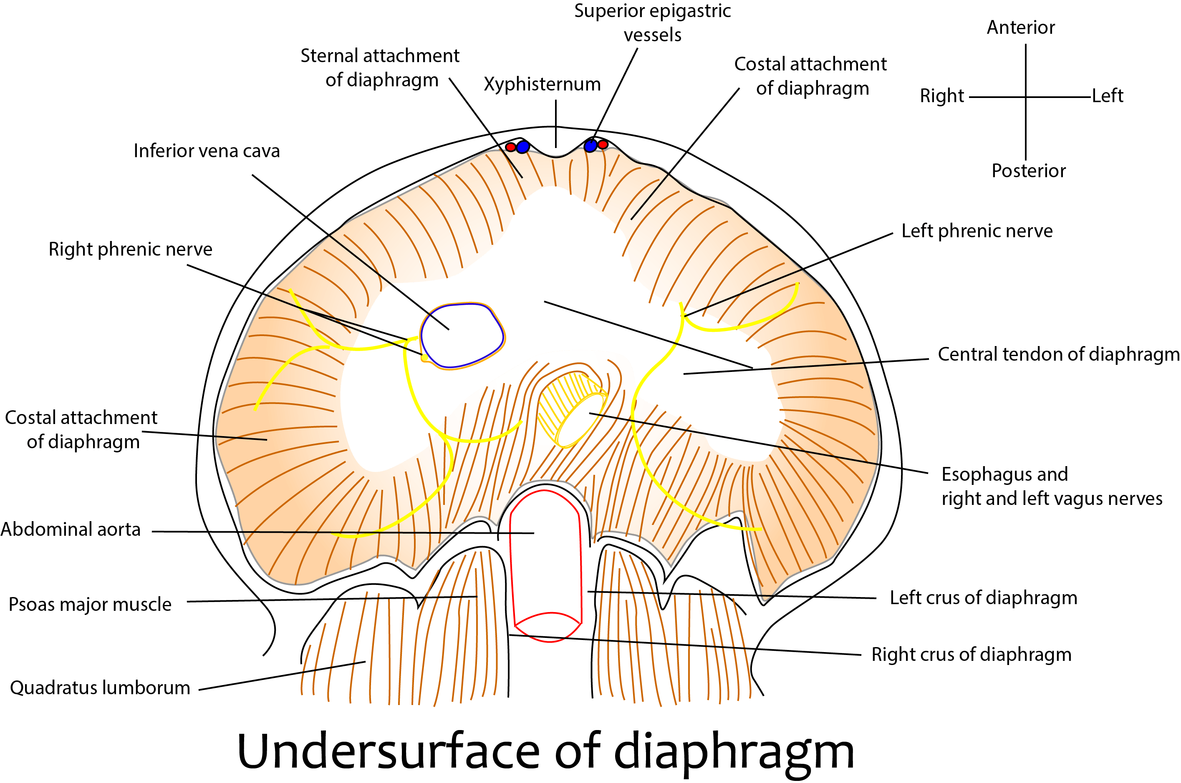

Embryonic Components
- Septum transversum (ventral mesoderm):
  - Forms the central tendon (non-muscular part).
  - Originates cranially (cervical region) between the heart and liver in week 3–4.
  - Provides the scaffold for myoblast migration and forms the fibrous central part.
- Pleuroperitoneal membranes (folds) (paired, dorsolateral):
  - Arise from the body wall in late week 4.
  - Grow medially and ventrally to fuse with the septum transversum and dorsal mesentery.
  - Close the pleuroperitoneal canals (pericardioperitoneal canals).
  - Form the major muscular portions of the diaphragm (except crura and periphery).
  - Right fold closes earlier than left (explains why left-sided defects are more common).
- Dorsal mesentery of esophagus:
  - Forms the crura of the diaphragm (right and left crus).
  - Surrounds the esophagus, aorta, and inferior vena cava at the hiatuses.
- Muscular ingrowth from lateral body wall (somitic mesoderm from cervical somites C3–C5):
  - Provides the peripheral muscular rim attached to the ribs and costal cartilages.
  - Myoblasts migrate into the other three components, bringing their nerve supply.

Sequence of Development & Descent
- Week 4: Septum transversum lies at cervical level (C3–C5). Pleuroperitoneal folds appear. Pericardioperitoneal canals are open.
- Weeks 5–6: Pleuroperitoneal membranes grow and fuse, closing the canals → separation of pleural and peritoneal cavities is complete.
- Weeks 6–8: Differential growth of the embryo (rapid caudal growth) causes apparent descent of the diaphragm from cervical to thoraco-lumbar level (final position opposite T8–T12 vertebrae).
[TIP]Phrenic nerve (derived from C3–C5 ventral rami) is carried downward with the descending diaphragm.

Innervation
- Motor and sensory supply to the entire diaphragm (except peripheral sensory from intercostal nerves) - phrenic nerve (C3, C4, C5)
[CLINICAL]Explains: Referred pain to shoulder tip (supraclavicular nerves C3–C4).

Hiatuses (formed during fusion)
- Caval opening (T8) – IVC.
- Esophageal hiatus (T10) – esophagus + vagi.
- Aortic hiatus (T12) – aorta, thoracic duct, azygos vein.
[YOUTUBE] https://www.youtube.com/watch?v=gnmMfipvaD4

Clinical Correlations
- Congenital Diaphragmatic Hernia (CDH): Failure of pleuroperitoneal membrane fusion.
  - Bochdalek hernia (posterolateral, 85–90%): Mostly left-sided → abdominal contents herniate into thorax → pulmonary hypoplasia, scaphoid abdomen, respiratory distress at birth.
  - Morgagni hernia (anterior/retrosternal): Smaller, often right-sided, later presentation.
- Eventration of diaphragm: Incomplete muscularization → thin, elevated hemidiaphragm.
- Phrenic nerve injury (birth trauma, surgery): Unilateral paralysis → elevated hemidiaphragm, dyspnea.
- Hiatal hernia (congenital/acquired): Enlarged esophageal hiatus.
____MCQ_START____
Q1. Which embryonic component primarily forms the central tendon of the diaphragm?
A. Pleuroperitoneal membranes
B. Dorsal mesentery of esophagus
C. Septum transversum[CORRECT]
D. Muscular ingrowth from lateral body wall (C3–C5 somites)
_____
Q2. The pleuroperitoneal membranes primarily contribute to which part of the diaphragm, and why are left-sided congenital diaphragmatic hernias (Bochdalek type) more common?
A. Central tendon; because right membrane closes later
B. Major muscular portions; because left fold closes later[CORRECT]
C. Crura; because septum transversum is asymmetric
D. Peripheral rim; because dorsal mesentery is weaker on left
_____
Q3. The phrenic nerve (C3–C5) innervates the diaphragm because:
A. It arises from thoracic somites and migrates caudally
B. The septum transversum originates at cervical levels (C3–C5), and the diaphragm descends during weeks 6–8, carrying the nerve supply downward [CORRECT]
C. Dorsal esophageal mesentery induces cervical nerve growth
D. Pleuroperitoneal membranes fuse at thoracic levels and recruit local nerves
____MCQ_END____

